FOR IMMEDIATE RELEASE
WaterFront – One Day to Make Craft a Part of Your Life

WaterFront Craft Art Market 2014
Kiwanis Park North (Spadina Cres. & 22nd St)
Saturday, June 28 from 10am – 7pm
FREE Admission

For one day only, visitors can head to Kiwanis Park North to purchase fine craft and art, participate in an interactive craft demonstration, and enjoy live music and fun activities for the whole family.

New date and location for Waterfront 2014:

This year marks a change for the well-known craft market. After taking place for several years on the second Saturday in June at River Landing, WaterFront is now calling Kiwanis Park North home, on the final Saturday of the month.
Says Saskatchewan Craft Council staff and market organizer Ferron Olynyk, "This is an exciting change for us. We are now situated, both physically and in terms of date, in the heart of festival season in Saskatoon. We are excited to be adjacent to the Jazz Festival mainstage, and really excited about some of our new partnerships, like the SaskMusic stage which will feature live music by local artists. We are looking forward to a great day!"

Waterfront takes place rain or shine!

Find the festival on Facebook via the Saskatchewan Craft Council page.

--

For more information please contact:
Ferron Olynyk, SCC Member Services
Saskatchewan Craft Council Phone: 306-653-3616, ext. 24
813 Broadway Avenue Email: scc.memberservices@sasktel.net
Saskatoon, SK S7N 1B5 Website: www.saskcraftcouncil.org

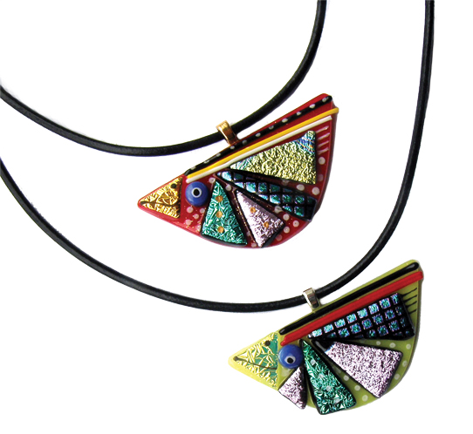
Joan and Al Hiebert – InGlassland – Booth 38

Judy Wood – Judy Wood Art/Photography – Booth 12

